

**FossTech & Tech Parsad** 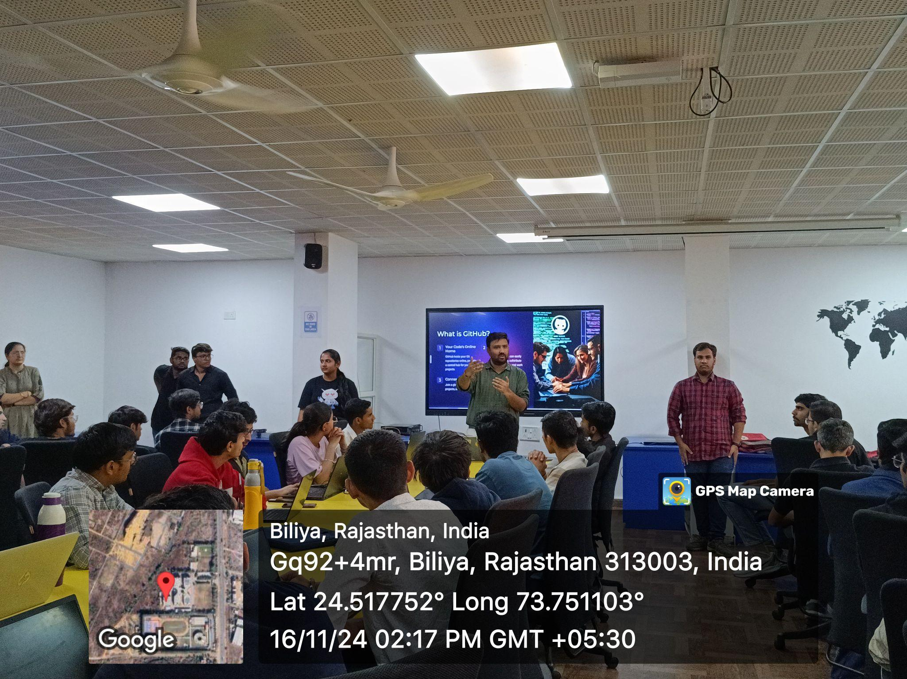

**Event Report: Introduction to Git and GitHub  
Organized by:** FossTech Club in collaboration with Tech Prasad  
**Date:** 16 November 2024  
**Time:** 2:00 PM to 4:00 PM  
**Venue:** I3 Lab

### **1. Objective**

The event's objective was to introduce participants to Git and GitHub, focusing on their essential functionalities and practical applications in collaborative software development. This session aimed to empower attendees with the skills to track changes, collaborate on projects, and effectively utilize GitHub as a tool for coding and version control.

### **2. Event Summary**

The session, jointly hosted by FossTech Club and Tech Prasad, was attended by students and developers eager to learn about Git and GitHub. It provided an opportunity for beginners to gain foundational knowledge while enabling more experienced attendees to refine their skills.

#### **Topics Covered**

1. **Setting up GitHub:**
   * Overview of GitHub and its applications.
   * Creating an account and configuring Git locally.
2. **Understanding Repositories, Commits, and Branches:**
   * Basics of repositories and how they function.
   * Concepts of commits and tracking changes.
   * Working with branches for project management.
3. **Collaborating on Projects:**
   * Sharing repositories and managing contributions.
   * Pull requests and resolve merge conflicts.

Interactive demonstrations were provided to enhance understanding and engagement.

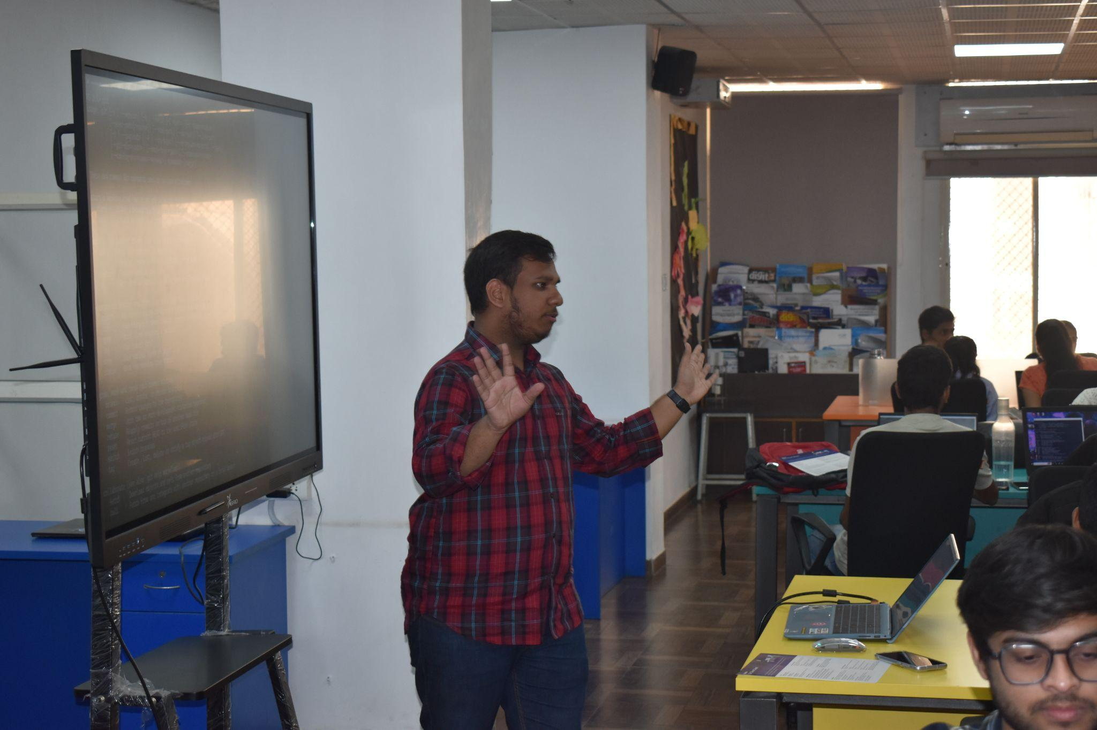

**Quiz and Gifts**

At the end of the session, a quiz was organized to test participants' understanding of the topics covered. The quiz was engaging and competitive, with participants showcasing their newly acquired knowledge. Exciting gifts were awarded to the top performers, adding an element of fun and motivation to the learning experience.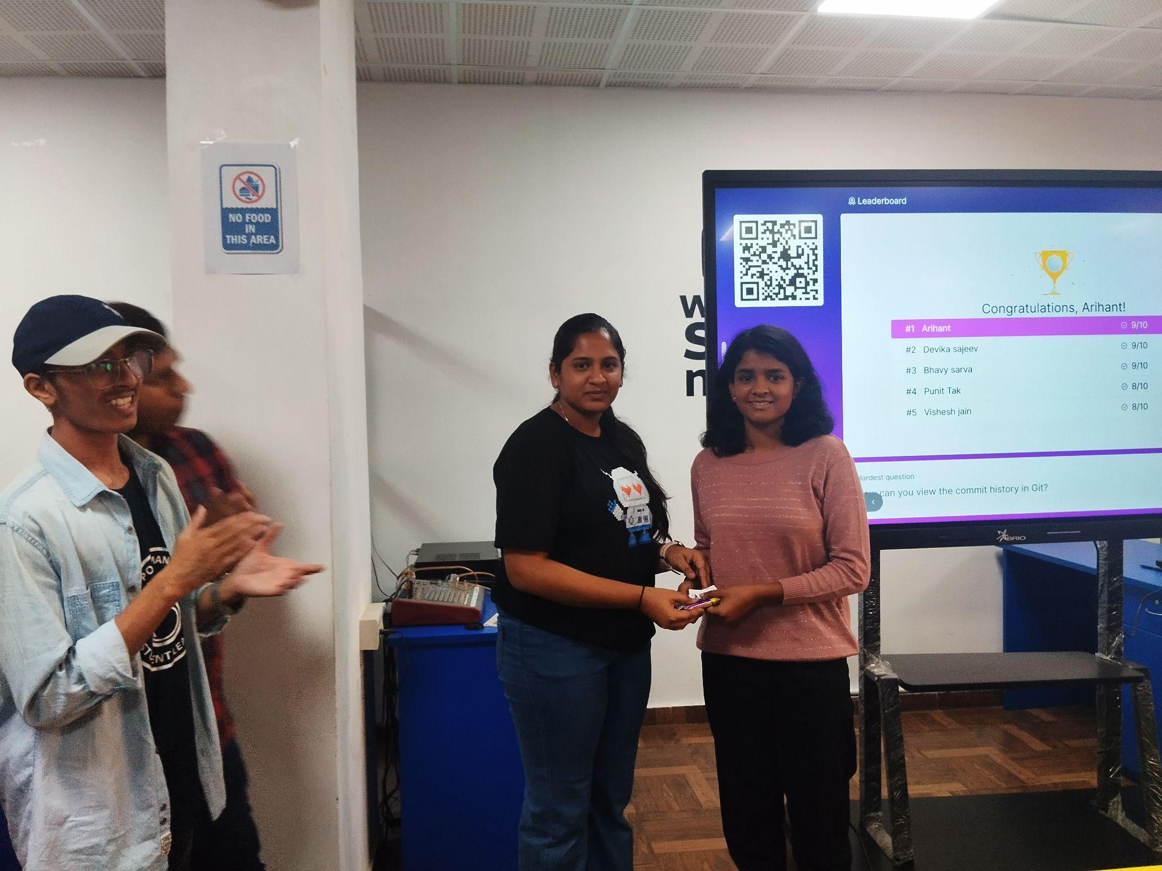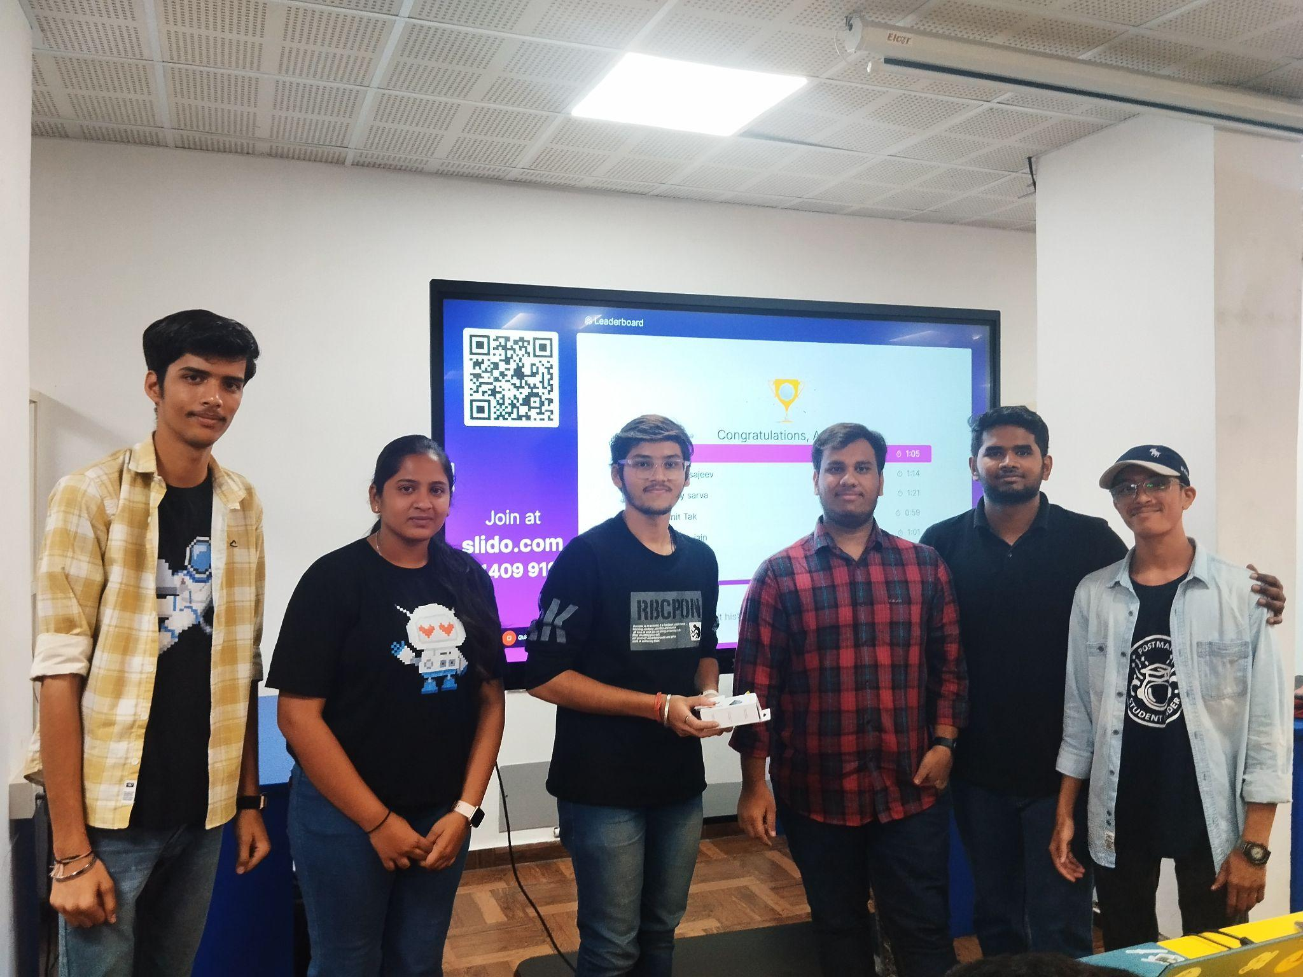

### 

### 

### 

### 

### 

### 

### **3. Highlights**

* **Collaboration:** The partnership between FossTech Club and Tech Prasad enriched the event, combining expertise and resources for a seamless experience.
* **Hands-on Practice:** Attendees followed along on their laptops, enabling immediate application of concepts.
* **Interactive Q&A:** The session concluded with a lively Q&A session where participants could clarify their doubts.
* **Engaging Quiz:** The post-session quiz provided an interactive way to reinforce learning and offered exciting gifts to winners.
* **Networking Opportunity:** The event fostered collaboration among peers with shared interests in coding and open source.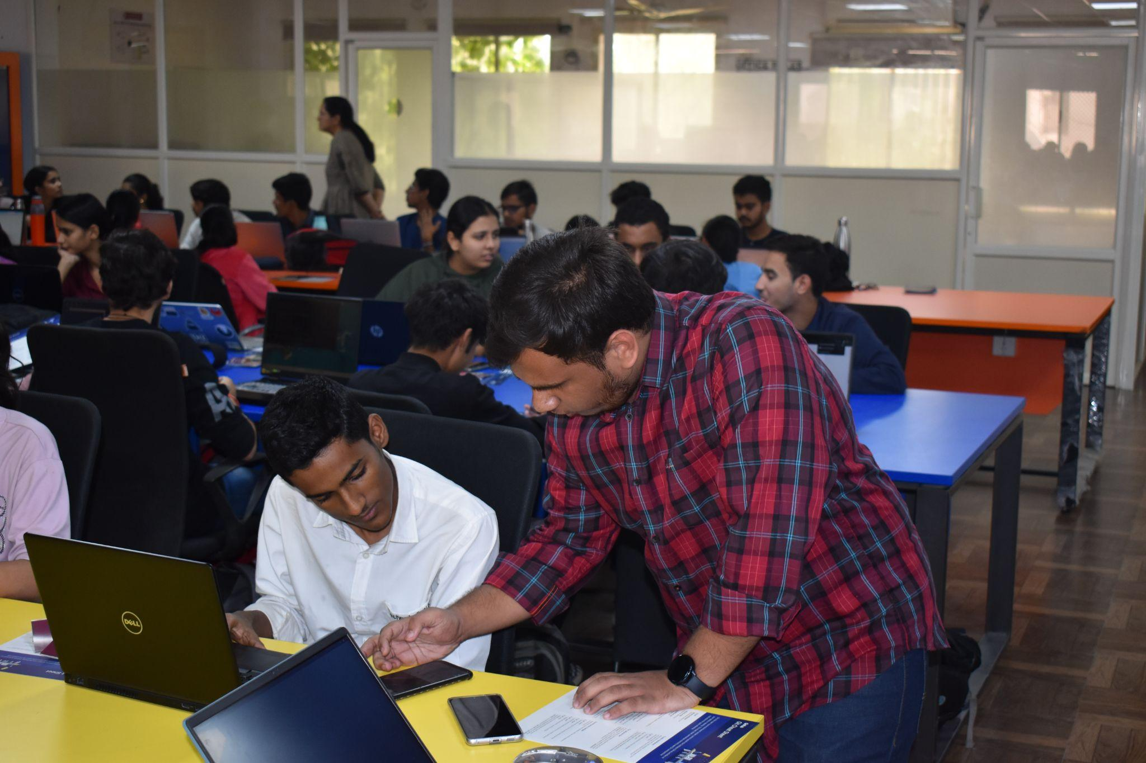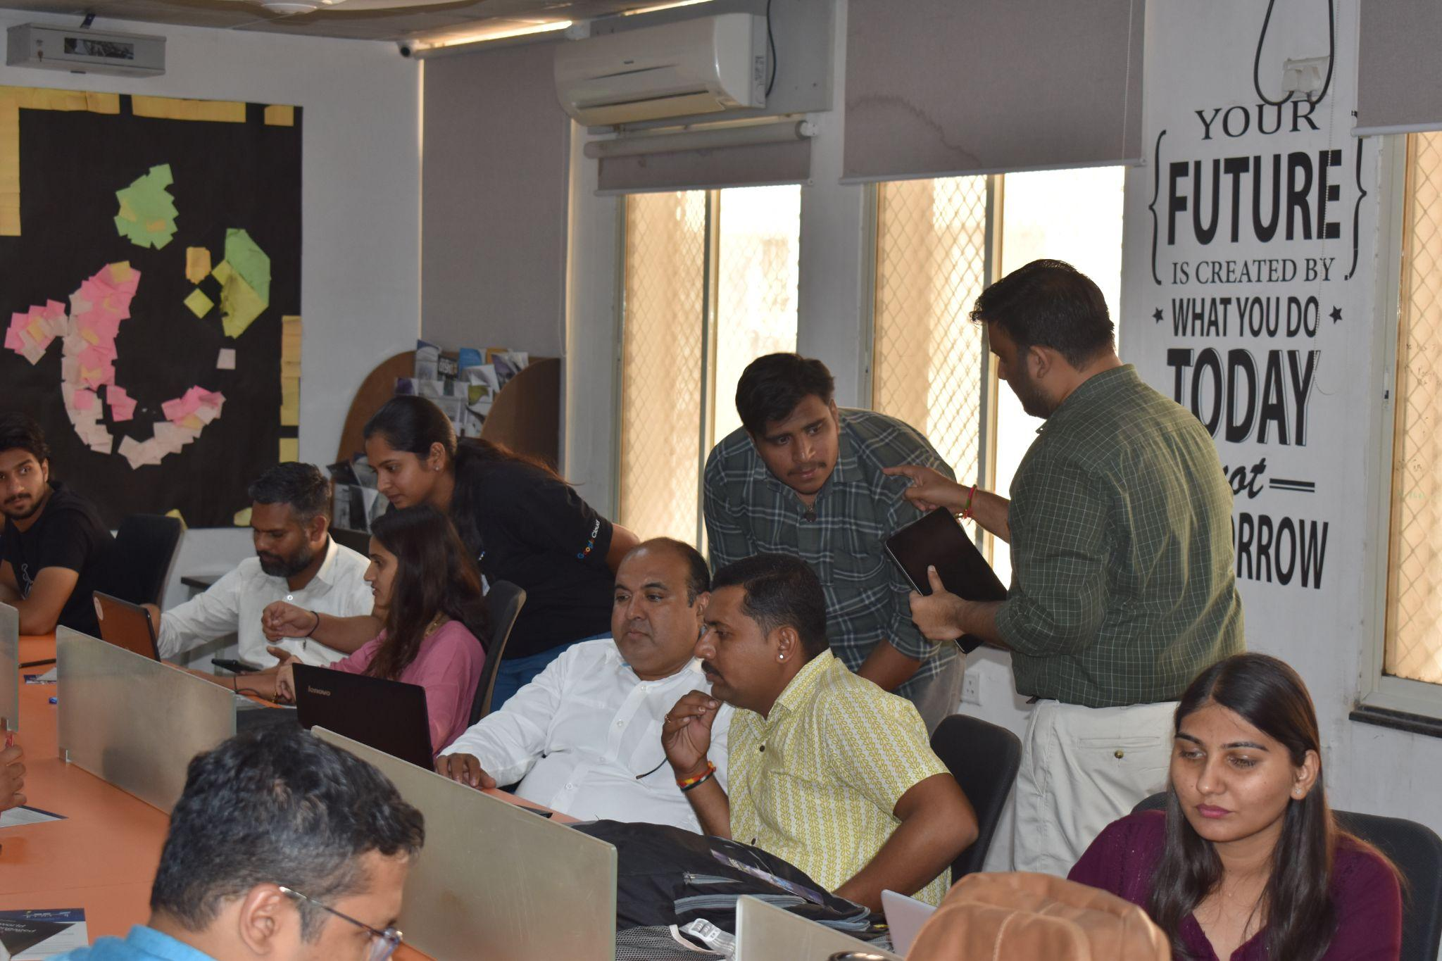

### **4. Participant Feedback**

Feedback collected from attendees indicated a high level of satisfaction with the event:

* **Engagement:** Participants appreciated the step-by-step explanations and practical approach.
* **Content Quality:** Many found the topics to be highly relevant and well-organized.
* **Excitement:** The quiz and gifts were well-received and praised for making the session enjoyable.
* **Suggestions for Improvement:** A few attendees suggested extending the session duration to explore advanced features of GitHub.

### **5. Conclusion**

The "Introduction to Git and GitHub" session, organized by FossTech Club and Tech Prasad, was a resounding success. Active participation, positive feedback, and engaging activities like the quiz with gifts made the event memorable. Both teams plan to organize similar workshops in the future, delving deeper into advanced GitHub functionalities and other tools that enhance productivity and collaboration in software development.